Ansible
Satya Kaveti
Ansible
2/16/20

Ansible – Introduction 3
Architecture 3
Workflow 5
Installation 6
Ubuntu 6
CentOS 7
YAML Basics 7
Ansible First Example 9
Ansible – Ad-hoc Commands 10
Ansible – Command Line Tools 11
Ansible – Modules 12
Ansible – Inventory 17
Inventory Hosts Example 17
Ansible – Master & Nodes/Hosts Configuration 18
Test Connection 19
More on Inventory 22
Ansible – Playbook 23
Playbook Language Example 23
Example: Copy file to hosts Example 25
Reusable Playbooks 27
Ansible – Roles 29
Create Ansible Role 29
Directory Structure of Ansible Role 29
Example : Install MEAN stack with Ansible Roles 30
Ansible - Loops 36
Ansible – Tags 37
Ansible – Templates 38
Ansible – Dynamic Inventory 40
Ansible – Tower 42
Ansible – Lab 42
Task 1: Create a user, install htop & nginx on all hosts. 43
Task 2 – WordPress Install 45
Step 1 — Installing Ansible 46
Step 2 - Create Roles 46
Inventory (hosts file) 50
playbook.yml 50
Test 51
Ref. 53
Errors 53
Ref. 54

Ansible – Introduction
- Ansible is an open-source configuration management and provisioning tool, similar to Chef, Puppet or Salt.

- It uses SSH to connect to servers and run the configured Tasks. Ansible lets you control and configure nodes from a single machine.

- What makes it different from other management software is that Ansible uses SSH infrastructure. The project was founded in 2013 and bought by Red Hat in 2015

Architecture
Ansible is entirely agentless, which means Ansible works by connecting your nodes through SSH (by default).
Ansible pushes small programs after connecting to your nodes which are known as "Ansible Modules". Ansible runs that module on your nodes and removes them when finished.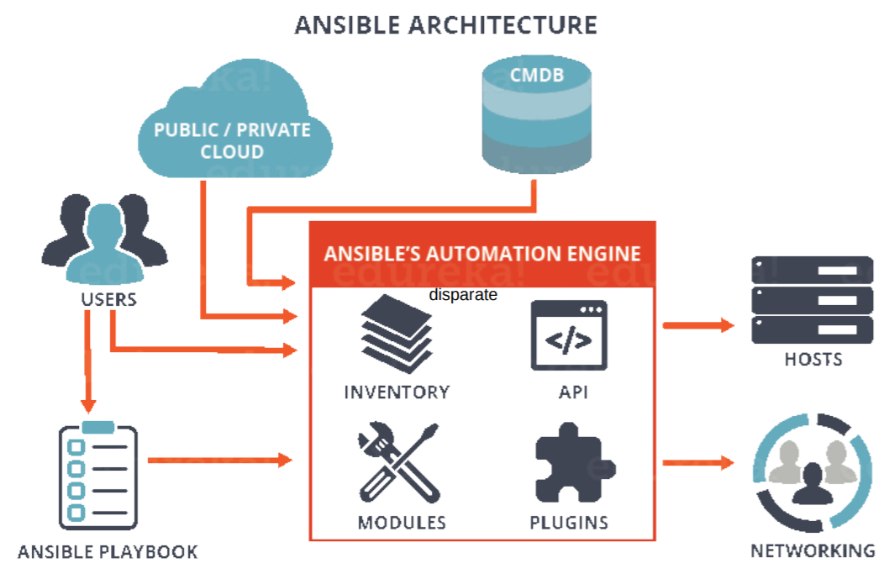

Control node
- Any machine with Ansible installed.
- You can run commands and playbooks, invoking /usr/bin/ansible or /usr/bin/ansible-playbook, from any control node.
- You can use any computer that has Python installed on it as a control node - laptops, shared desktops, and servers can all run Ansible.
- However, you cannot use a Windows machine as a control node. You can have multiple control nodes.

Managed nodes
The network devices (and/or servers) you manage with Ansible. Managed nodes are also sometimes called “hosts”. Ansible is not installed on managed nodes.

Inventory
- A list of managed nodes.
- An inventory file is also sometimes called a “hostfile”. default location is in./etc/ansible/hosts
- Your inventory can specify information like IP address for each managed node.
- Every host is assigned to a group such as web servers, db servers etc.
- The inventory file can be in one of many formats such as yaml, INI etc
Example of an Inventory file

mail.example.com

[webservers]
foo.example.com
bar.example.com

[dbservers]
one.example.com
two.example.com
three.example.com

Modules
- The units of code Ansible executes.
- You can invoke a single module with a task, or invoke several different modules in a playbook
- There are over 1000 modules(kind of jars) provided by Ansible to perform specific task.
- Modules are like plugins; they are what gets executed in each playbook task.
- Each module is mostly standalone and can be written in a standard scripting language (such as Python, Perl, Ruby, Bash, etc.).
# Example of Modules
There are lots of modules such as :
Service, file, copy, iptables etc.

Any Module can be used as :
ansible 127.0.0.1 -m service -a "name=httpd state=started"
ansible localhost -m ping

Tasks
The units of action in Ansible. You can execute a single task once with an ad-hoc command.

Playbook
- Playbooks are simple YAML files.
- Playbooks make your installations, upgrades and day-to-day management repeatable things.
- Playbooks are simple to write and maintain.
Playbook contains Plays.
|
Plays contain tasks.
|
tasks call modules.

#Example of an ansible playbook
---
- hosts: webservers
remote_user: root
tasks:
- name: ensure apache is at the latest version
yum: name=httpd state=latest
- name: ensure apache is running
service: name=httpd state=started enabled=yes

Roles
- In Ansible, the role is the primary mechanism for breaking a playbook into multiple files. This simplifies writing complex playbooks, and it makes them easier to reuse
- Playbook is a collection of Roles
- Each Role will have a Specific functionality
- Ansible Roles are Independent on each other.
- hosts: all
roles:
- role_1
- role_2

Workflow
Ansible works by connecting to your nodes and pushing out a small program called Ansible modules to them. Then Ansible executed these modules and removed them after finished.
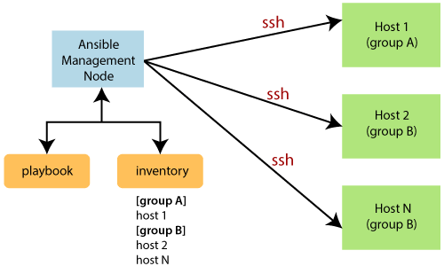
- In the above image, the Management Node is the controlling node that controls the entire execution of the playbook.
- The inventory file provides the list of hosts where the Ansible modules need to be run.
- The Management Node makes an SSH connection and executes the small modules on the host's machine and install the software.
Ansible has three main files that you need to consider:
- Host/inventory file: Contains the entry of the nodes that need to be managed
- Ansible.cfg file: Located by default at /etc/ansible/ansible.cfg, it has the necessary privilege escalation options and the location of the inventory file
- Main file: A playbook that has modules that perform various tasks on a host listed in an inventory or host file

Installation

Ubuntu
#1:First perform an update to the packages
sudo apt update

#2:Then install the software properties common package.
sudo apt install software-properties-common

#3:Install the Ansible personal package archive.
sudo apt-add-repository ppa:ansible/ansible

#4:Install the Ansible.
sudo apt update
sudo apt install ansible

CentOS
#Install the EPEL repo
sudo yum install epel-release

#Install the Ansible package.
sudo yum install -y ansible

Check the installation
ansible --version
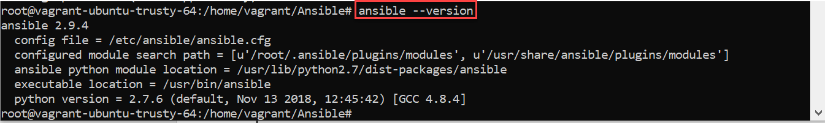

YAML Basics
YAML starts with --- and end with ... This indicates the start and end of a YAML document.
YAML List
Nearly every YAML file starts with a list. Each item in the list is a list of key/value pairs
---
# A list of tasty fruits
- Apple
- Orange
- Strawberry
- Mango
...

Dictionary
A dictionary is represented in a simple `key: value` form (the colon must be followed by a space):
# An employee records
martin:
name: Martin D'vloper
job: Developer
skill: Elite

Boolean
We can specify Boolean value (true/false) in several forms:
create_key: yes
needs_agent: no
knows_oop: True
likes_emacs: TRUE
uses_cvs: false
Large Values can span multiple lines using | or >.
include_newlines: |
exactly as you see
will appear these three
lines of poetry

fold_newlines: >
this is really a
single line of text
despite appearances

Let’s combine what we learned so far in an arbitrary YAML example.
# An employee records
---
name: Martin D'vloper
job: Developer
skill: Elite
employed: True
foods:
- Apple
- Orange
- Strawberry
- Mango
languages:
perl: Elite
python: Elite
pascal: Lame
education: |
4 GCSEs
3 A-Levels
BSc in the Internet of Things

Variables
uses “{{ var }}” for variables. If we want to use previously declared variable, we must place between "{{ --var-- }}"
foo: "{{ variable }}"

- A colon followed by a space (or newline) ": " is an indicator for a mapping.
- A space followed by the pound sign " #" starts a comment.
https://docs.ansible.com/ansible/latest/reference_appendices/YAMLSyntax.html

Ansible First Example
For any ansible configuration , we need two files
- Inventory File – contains list of hosts
- Playbook - Contains tasks to be executed on inventory hosts
1.Inventory file
Here we are using default inventory host file located in /etc/ansible/hosts, contains single node
192.168.33.11 ansible_user=vagrant

Test Connection
ansible all -m ping -k -b

2.Playbook
We are creating helloworld.yml with below content
---
- name: This is a hello-world example
hosts: all
tasks:
- name: Create a file called '/tmp/testfile.txt' with the content 'hello world'.
copy:
content: hello world
dest: /tmp/testfile.txt

3.Run playbook
ansible-playbook helloworld.yml -i /etc/ansible/hosts
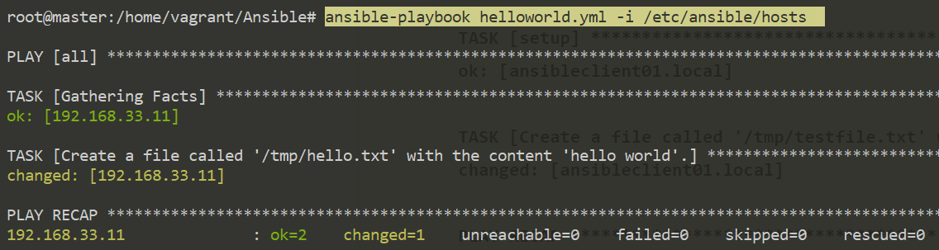
Here we are using default hosts file, so we are not requited to specify inventory file manullay, above playbook will work with below command as well.
ansible-playbook helloworld.yml

Ansible – Ad-hoc Commands
An Ansible ad-hoc command uses the /usr/bin/ansible command-line tool to automate a single task on one or more managed nodes. Ad-hoc commands are great for tasks you repeat rarely.
for example, if you want to power off all the machines in your lab for Christmas vacation, you could execute a quick one-liner in Ansible without writing a playbook.
Syntax
ansible [hsotpattern] -m [module] -a "[module options]"

Ad-hoc tasks can be used to reboot servers, copy files, manage packages and users etc.
Ex #1 - I want to re-boot all [web] servers
ansible web -a "/sbin/reboot"

Ex #2 - By default Ansible uses only 5 simultaneous processes, I have 100 Servers - To reboot the [web] servers with 10 parallel forks/processes
ansible web -a "/sbin/reboot" -f 10

Copy Module : used for transfer files from Master to host nodes.
# To transfer a file from Ansible master to all servers in the [web] group:
ansible web -m copy -a "src=/etc/hosts dest=/tmp/hosts"

File Module : used for Create/Copy/Delete files or folders from Hosts
# file module allows changing ownership and permissions on files.
ansible web -m file -a "dest=/srv/foo/a.txt mode=600"
ansible web -m file -a "dest=/srv/foo/b.txt mode=600 owner=mdehaan group=mdehaan"

#The file module can also create directories, similar to mkdir -p:
ansible web -m file -a "dest=/path/to/c mode=755 owner=mdehaan group=mdehaan state=directory"

#To delete directories (recursively) and delete files:
ansible webservers -m file -a "dest=/path/to/c state=absent"

yum Module: to install, update, or remove packages on managed nodes
# To ensure a specific version of a package is installed:
$ ansible webservers -m yum -a "name=acme-1.5 state=present"

# To ensure a package is at the latest version:
$ ansible webservers -m yum -a "name=acme state=latest"

# To ensure a package is not installed:
$ ansible webservers -m yum -a "name=acme state=absent"

user Module: create, manage, and remove user accounts
$ ansible all -m user -a "name=foo password=<crypted password here>"
$ ansible all -m user -a "name=foo state=absent"

service Module: start/stop services
# Ensure a service is started on all webservers:
$ ansible webservers -m service -a "name=httpd state=started"

# restart a service on all webservers:
$ ansible webservers -m service -a "name=httpd state=restarted"

# Ensure a service is stopped:
$ ansible webservers -m service -a "name=httpd state=stopped"

Ansible – Command Line Tools
- ansible
Used to Define and run a single task ‘playbook’ against a set of hosts. Mostly we used this for running Ad-hoc commands
ansible web -a "/sbin/reboot"

- ansible-config
View ansible configuration.
vagrant@master:~/Ansible$ ansible-config --version
ansible-config 2.9.4
config file = /etc/ansible/ansible.cfg
configured module search path = [u'/home/vagrant/.ansible/plugins/modules', u'/usr/share/ansible/plugins
/modules']
ansible python module location = /usr/lib/python2.7/dist-packages/ansible
executable location = /usr/bin/ansible-config
python version = 2.7.6 (default, Nov 13 2018, 12:45:42) [GCC 4.8.4]

- ansible-console
a REPL that allows for running ad-hoc tasks against a chosen inventory

- ansible-doc
displays information on modules installed in Ansible libraries. It displays a terse listing of plugins and their short descriptions, provides a printout of their DOCUMENTATION strings, and it can create a short “snippet” which can be pasted into a playbook.

- ansible-galaxy
command to manage Ansible roles in shared repositories, the default of which is Ansible Galaxy https://galaxy.ansible.com.

- ansible-inventory
used to display or dump the configured inventory as Ansible sees i

- ansible-playbook
Runs Ansible playbooks, executing the defined tasks on the targeted hosts.

- ansible-pull
pulls playbooks from a VCS repo and executes them for the local host

- ansible-vault
encryption/decryption utility for Ansible data files

Ansible – Modules
Ansible modules are standalone scripts that can be used inside an Ansible playbook. A playbook consists of a play, and a play consists of tasks.
1. Package management
- There is a module for most popular package managers, such as DNF and APT, to enable you to install any package on a system.
- It covers YUM module (required for Python 2 compatibility) is yum_module, while the APT module is apt_module, the Slackpkg module is slackpkg_module, and so on.
Example
- name: Install a list of packages
yum:
name:
- nginx
- postgresql
- postgresql-server
state: present
This installs the list of packages and helps download multiple packages

2: Service
After installing a package, you need a module to start it. The service module enables you to start, stop, and reload installed packages; this comes in pretty handy.

Example 1:
- name: Start service foo, based on running process /usr/bin/foo
service:
name: foo
pattern: /usr/bin/foo
state: started
This starts the service foo.
Example 2:
- name: Restart network service for interface eth0
service:
name: network
state: restarted
args: eth0
This restarts the network service of the interface eth0.

3: Copy
The copy module copies a file from the local or remote machine to a location on the remote machine.
Example 1:
- name: Copy a new "ntp.conf file into place, backing up the original if it differs from the copied version
copy:
src: /mine/ntp.conf
dest: /etc/ntp.conf
owner: root
group: root
mode: '0644'
backup: yes

Example 2:
- name: Copy file with owner and permission, using symbolic representation
copy:
src: /srv/myfiles/foo.conf
dest: /etc/foo.conf
owner: foo
group: foo
mode: u=rw,g=r,o=r

4.File
The file module manages the file and its properties.
- It sets attributes of files, symlinks, or directories.
- It also removes files, symlinks, or directories.

Example 1:
- name: Change file ownership, group and permissions
file:
path: /etc/foo.conf
owner: foo
group: foo
mode: '0644'
This creates a file named foo.conf and sets the permission to 0644.
Example 2:
- name: Create a directory if it does not exist
file:
path: /etc/some_directory
state: directory
mode: '0755'
This creates a directory named some_directory and sets the permission to 0755.

5.Lineinfile
The lineinfile module manages lines in a text file.
- It ensures a particular line is in a file or replaces an existing line using a back-referenced regular expression.
- It's primarily useful when you want to change just a single line in a file.
Example 1:
- name: Ensure SELinux is set to enforcing mode
lineinfile:
path: /etc/selinux/config
regexp: '^SELINUX='
line: SELINUX=enforcing
This sets the value of SELINUX=enforcing.
Example 2:
- name: Add a line to a file if the file does not exist, without passing regexp
lineinfile:
path: /etc/resolv.conf
line: 192.168.1.99 foo.lab.net foo
create: yes
This adds an entry for the IP and hostname in the resolv.conf file.

6.User Module
The module manages users accounts with there attributes. This is handy do to the fact that the user properties and attributes can all be configured from this Ansible module.

Example
# Add the user 'exampleuser' with a specific uid and a primary group of 'admin'
- user:
name: exampleuser
comment: "Example User"
uid: 1040
group: admin# Remove the user 'exampleuser'
- user:
name: exampleuser
state: absent
remove: yes

7.shell module
Ansible’s shell module executes shell commands on remote hosts.
- name: create a text file in $HOME with the /bin/sh shell
shell: echo "Hello, World!" > $HOME/test_file.txt

- name: read all text files in $HOME with the /bin/bash shell
shell: cat < $HOME/*.txt
args:
executable: /bin/bash

8.Ansible Apt
APT stands for "Advanced Packaging Tool" , It allows us to install new packages, update them, and remove the packages from Ubuntu systems. Here are 3 APT related command-line tools, such as:
- Apt-get: All the basic package management operations can be done by using this tool. Ansible apt-get module provides this functionality.
- Apt-add-repository: It is used for adding a new repository to the repository list. The default repository may not have the latest version of all the packages. So you need to add additional repositories for some software maintainers. Ansible apt_repository module provides the functionality for adding a new repository.
- Apt-key: It is used to manage the list of keys for authenticating apt packages. Ansible apt_key module is used to manage the keys.

Installing new Apt Packages
- To install the new packages, you have to give the name of the package in the name parameter and the desired state of the package.
- The default state of the package is "present". Also, it is better to set the update_cache to true.
- The below example will do a cache update to synchronize the index. Check if the 'zip' package is installed on the target server. And if it is not installed, the package will be installed. If the package is already installed, then it won't be upgraded.
-hosts: loc
tasks:
-name: Ansible apt install packages
apt:
name: zip
state: present
update_cache: true

1. Installing the latest version of a package
If you set the state of the packages to "present", then Ansible will only check if the package is present. So if the new package is available, it will not be able to install.
-hosts: loc
tasks:
-name: ansible apt install latest version
apt:
name: zip
state: latest
update_cache: true

2. Ansible install multiple packages
In the below example, we are going to install 3 packages: docker-ce, Nginx, and git.
-hosts: loc
tasks:
-name: ansible apt with_items
apt:
name: "{{item}}"
update_cache: true
state: present
with_items:
-'docker-ce'
-'nginx'
-'git'

3.Removing Apt Packages
You can also remove the packages using apt module by setting the state parameter to absent.
-hosts: loc
tasks:
-name: ansible apt remove package
apt:
name: zip
state: absent

Ansible – Inventory
Ansible works against multiple managed nodes or “hosts” in your infrastructure at the same time, using a list or group of lists know as inventory.
- Inventory file contains list of Nodes & their IP/Hostnames
- The default location for inventory is a file called /etc/ansible/host.
- You can also specify a different inventory file at the command line using the -i <path> option.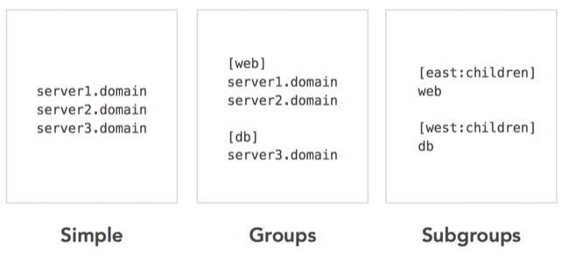
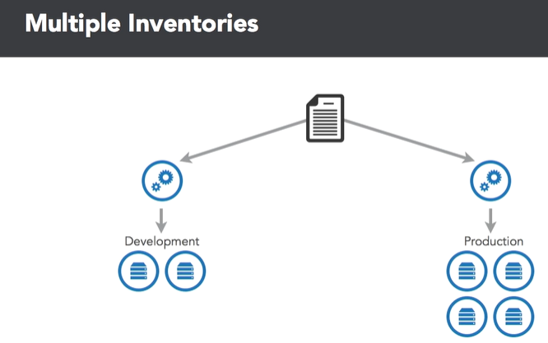

Inventory Hosts Example
# /home/vagrant/Ansible/inventory
[all]
web1 ansible_ssh_host=web1.satyacodes.vm
web2 ansible_ssh_host=web2.satyacodes.vm
db1 ansible_ssh_host=db1.satyacodes.vm
db2 ansible_ssh_host=db2.satyacodes.vm
[web]
web1
web2
[db]
db1
db2
[backup]
db2
Here we have [Groups], each group have hosts

Ansible – Master & Nodes/Hosts Configuration
I have placed a host inside /home/vagrant/Ansible/inventory_test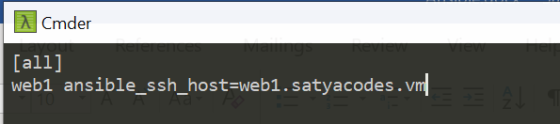

Hosts - Changing Hostnames in Ubuntu
If you want to change hostname to - web1.satyacodes.vm then you follow below steps
Open below files in editor & place hostname inside that.
sudo vi /etc/hostname

sudo reboot
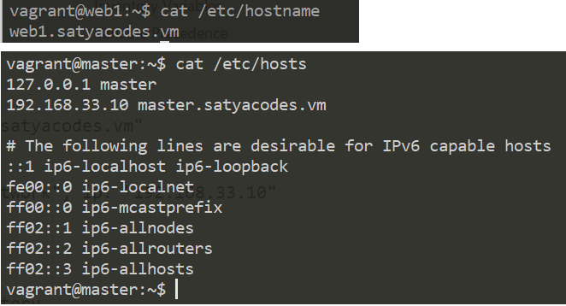

Change Hostname in Vagrant
If you are using Vagrant, Edit vagrant file with
config.vm.hostname = "master.satyacodes.vm"

#To chane IP
config.vm.network "private_network", ip: "192.168.33.10"

Master – configure Hosts IP address with Hostnames
We need to tell our master, while resolving hostname, given host(web1.satyacodes.vm) is pointed to this IP(192.168.33.11).for that we need to specify IPAddress <Hostname> mappings in /etc/hosts file
#sudo vi /etc/hosts
192.168.33.10 master.satyacodes.vm
192.168.33.11 web1.satyacodes.vm
192.168.33.12 web2.satyacodes.vm
192.168.33.13 db1.satyacodes.vm
192.168.33.14 db2.satyacodes.vm

Test Connection
So, I have an inventory_test with a single host, which is grouped under [all] with a key web1
# home/vagrant/Ansible/inventory_test
[all]
web1 ansible_ssh_host=web1.satyacodes.vm

Test connection using ping
Here Iam trying to connect to machines and run a ping command on nodes using ansible.
ansible -i inventory_test all -m ping

#Output
root@master:/home/vagrant/Ansible# ansible -i inventory_test all -m ping
web1 | UNREACHABLE! => {
"changed": false,
"msg": "Failed to connect to the host via ssh: ssh: Could not resolve hostname web1.satyacodes.vm: Name or service not known",
"unreachable": true
}
If you Got above error, means master unable to connect with hosts, because we haven’t configured SSH / Usernames:password to connect with Hosts.
To connect with Hosts from Ansible Master node, we must configure the Login mechanism.
we can do this by in two ways
- Username/pwd Authentication
- SSH Authentication

1.Username/pwd Authentication
# home/vagrant/Ansible/inventory_test
[all]
127.0.1.1 ansible_connection=ssh ansible_ssh_user=vagrant ansible_ssh_pass=vagrant
Or
# home/vagrant/Ansible/inventory_test
[all]
web1.satyacodes.vm ansible_connection=ssh ansible_ssh_user=vagrant ansible_ssh_pass=vagrant

ansible -i inventory_test all -m ping
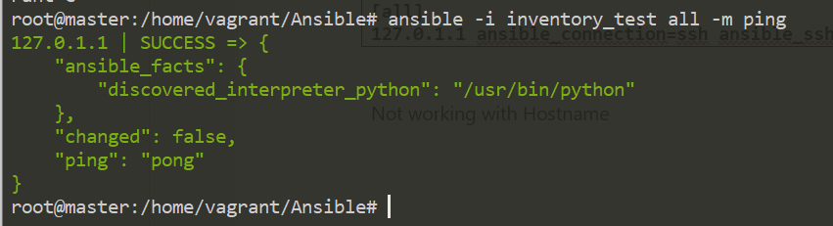
Sometimes we get below error.
using a ssh password instead of a key is not possible because host key checking is enabled and sshpass does not s upport this. please add this host's fingerprint to your known_hosts file to manage this host

To Resolve this Run, export ANSIBLE_HOST_KEY_CHECKING=False
Because, this is typically done by setting the following value in ansible.cfg:
[defaults]
host_key_checking = False

If you don't want to modify ansible.cfg you can set an environment variable like so:
export ANSIBLE_HOST_KEY_CHECKING=False

2.SSH key Authentication
Generate ssh key in the ansible master, which we have to copy to all the remote hosts for doing deployments or configurations on them.
To Generate SSH key, run ssh-keygen
root@master:/home/vagrant/Ansible# ssh-keygen
Generating public/private rsa key pair.
Enter file in which to save the key (/root/.ssh/id_rsa):
/root/.ssh/id_rsa already exists.
Overwrite (y/n)? y
Your identification has been saved in /root/.ssh/id_rsa.
Your public key has been saved in /root/.ssh/id_rsa.pub.
The key fingerprint is:
15:95:ba:2a:3f:d6:92:af:b6:61:a7:f8:ff:76:43:57 root@master
The key's randomart image is:
The key's randomart image is:
+--[ RSA 2048]----+
| .. E|
| .**Boo.. . |
+-----------------+
- Your identification has been saved in /root/.ssh/id_rsa.
- Your public key has been saved in /root/.ssh/id_rsa.pub.
Now we need copy public key of Ansible Master to its nodes/hosts. Here my host ip is : 192.168.33.11
ssh-copy-id -i <user>@<ip address of your node machine>
ssh-copy-id -i vagrant@192.168.33.11

If you got Error : Permission denied (publickey,gssapi-keyex,gssapi-with-mic).
- Go to /etc/ssh/sshd_config
- uncomment 'PasswordAuthentication yes'
- re-start the service 'sudo systemctl restart sshd'
Similarly copy MASTER public SSH Key to all the hosts(if you have many hosts )
ssh-copy-id -i vagrant@192.168.33.12
ssh-copy-id -i vagrant@192.168.33.13
ssh-copy-id -i vagrant@192.168.33.14

To Test, now write an Inventory file & Don’t write Credentials to It.
# /home/vagrant/Ansible/inventory_ssh
[all]
web1 ansible_ssh_host=web1.satyacodes.vm

Ping above Inventory hosts Using Ansible
ansible -i inventory_ssh all -m ping

Error:Failed to connect to the host via ssh: Permission denied (publickey,password).
We must include username
web1 ansible_ssh_host=web1.satyacodes.vm ansible_user=vagrant

root@master:/home/vagrant/Ansible# ansible -i inventory_ssh all -m ping
web1 | SUCCESS => {
"ansible_facts": {
"discovered_interpreter_python": "/usr/bin/python"
},
"changed": false,
"ping": "pong"
}

Once, that is done, you can restart the sshd service on your target server by running:
$ service sshd restart

The next task is to test whether the ssh connection works. From build-server run:
$ ssh username@ip.address.of.host

More on Inventory

Adding variables to inventory
you may add variables directly to the hosts and groups in your main inventory file.
[atlanta]
host1 http_port=80 maxRequestsPerChild=808
host2 http_port=303 maxRequestsPerChild=909
Mostly we will use variables, to provide connection details like port, ssh ,username, pwd etc
[targets]
localhost ansible_connection=local
other1.example.com ansible_connection=ssh ansible_user=myuser
other2.example.com ansible_connection=ssh ansible_user=myotheruser

If all hosts in a group share a variable value, you can apply that variable to an entire group at once.
[atlanta]
host1
host2

[atlanta:vars]
ntp_server=ntp.atlanta.example.com
proxy=proxy.atlanta.example.com

Inventory aliases
You can also define aliases in your inventory
web ansible_port=5555 ansible_host=192.0.2.50
In the above example, running Ansible against the host alias “web” will connect to 192.0.2.50 on port 5555

Adding ranges of hosts
If you have a lot of hosts with a similar pattern, you can add them as a range, separated by ` : `
[webservers]
www[01:50].example.com

You can also define alphabetic ranges:
[databases]
db-[a:f].example.com

Using multiple inventory sources
You can target multiple inventory sources at the same time by giving multiple inventory parameters separated by -i.
This can be useful when you want to target separate environments, like staging and production, at the same time for a specific action. Target two sources from the command line like this:
ansible-playbook get_logs.yml -i staging -i production

Ansible – Playbook
Playbooks are Ansible’s configuration, deployment, and orchestration language. Playbooks can be used to manage configurations of and deployments to remote machines.

Playbook Language Example
- Playbooks are expressed in YAML format.
- Each playbook is composed of one or more ‘plays’ in a list.
- Playbooks can contain multiple plays. You may have a playbook that targets first the web servers, and then the database servers. For example:
---
- hosts: webservers
remote_user: root

tasks:
- name: ensure apache is at the latest version
yum:
name: httpd
state: latest
- name: write the apache config file
template:
src: /srv/httpd.j2
dest: /etc/httpd.conf

- hosts: databases
remote_user: root

tasks:
- name: ensure postgresql is at the latest version
yum:
name: postgresql
state: latest
- name: ensure that postgresql is started
service:
name: postgresql
state: started

Playbook Explanation

Hosts and Users
For each play in a playbook, you get to choose which machines in your infrastructure to target and what remote user to complete the tasks.
---
- hosts: webservers
remote_user: root

Remote users can also be defined per task:
---
- hosts: webservers
remote_user: root
tasks:
- name: test connection
ping:
remote_user: yourname

Ansible Supports for running things as another user is also available, using become:yes variable
---
- hosts: webservers
remote_user: yourname
become: yes

You can also login as you, and then become a user different than root:
---
- hosts: webservers
remote_user: yourname
become: yes
become_user: postgresql

Tasks
Each play contains a list of tasks. Tasks are executed in order, one at a time, against all machines matched by the host pattern, before moving on to the next task.
tasks:
- name: make sure apache is running
service:
name: httpd
state: started
- Every task should have a name, which is included in the output from running the playbook.
- The goal of each task is to execute a module(in above - its `service`), with very specific arguments. Variables can be used in arguments to modules.
- Tasks can be declared using the legacy `action: module options` format, but it is recommended to use `module: options` format.
- Each module may `key=value` arguments
The command and shell modules are the only modules that just take a list of arguments.
tasks:
- name: enable selinux
command: /sbin/setenforce 1

tasks:
- name: run this command and ignore the result
shell: /usr/bin/somecommand || /bin/true

Playbook Variables
Playbook variables are Similar to YAML dictionaries. To define a variable in a playbook, simply use the keyword vars before writing your variables with indentation.
To access the value of the variable “{{ <variable >}}”
Here’s a simple playbook example:
- hosts: all
vars:
greeting: Hello world!

tasks:
- name: Ansible Basic Variable Example
debug:
msg: "{{ greeting }}"

Example: Copy file to hosts Example
- create a file called tmp/file in all hosts `-- hosts: all`
- create a file only in [web] hosts `-- hosts: web`
- create a file in all hosts, except [db] hosts
- create a file in all hosts & [backup] hosts, except [web] hosts
- Touch – will create the file if doesn’t exist
- Absent – will remove specified files

1.Inventory file
I have following hosts, which are placed in an Inventory file in this location (/home/vagrant/Ansible/inventory)
# /home/vagrant/Ansible/inventory
[all]
web1 ansible_ssh_host=192.168.33.11
web2 ansible_ssh_host=192.168.33.12
db1 ansible_ssh_host=192.168.33.13
db2 ansible_ssh_host=192.168.33.14
[web]
web1
web2
[db]
db1
db2
[backup]
db2
Here we have [Groups], each group have hosts
Test the Connection , by ping
Here I’m trying to connect to machines and run a ping command on nodes using ansible.
ansible -i inventory all -m ping

2.Playbook yml
Remember – all playbooks start with ---(there dashs) because its YAML file. Save playbook in .yml extension(playbook1_copyfile.yml)
---
- hosts: all
tasks:
- name: create a file on a remote machine
file:
dest: /tmp/file
state: '{{file_state}}'

- hosts: web
tasks:
- name: create file on web machines
file:
dest: /tmp/web-file
state: '{{file_state}}'

- hosts: all:!db
tasks:
- name: create file on all hosts - Except DB hosts
file:
dest: /tmp/all-but-not-db-file
state: '{{file_state}}'

- hosts: all:&backup:!web
tasks:
- name: create file on all hosts and BACKUP hosts- Except DB hosts
file:
dest: /tmp/all-and-backup-file-not-web
state: '{{file_state}}'
{{file_state}} - we are passing {{file_state}} variable at RUNTIME

3.Run play in inventory hosts
Syntax:
ansible-playbook -i <inventory_file> <playbook_yml_file>.yml -e <envi_varible>=<value>

ansible-playbook -i inventory playbook1_copyfile.yml -e file_state=touch

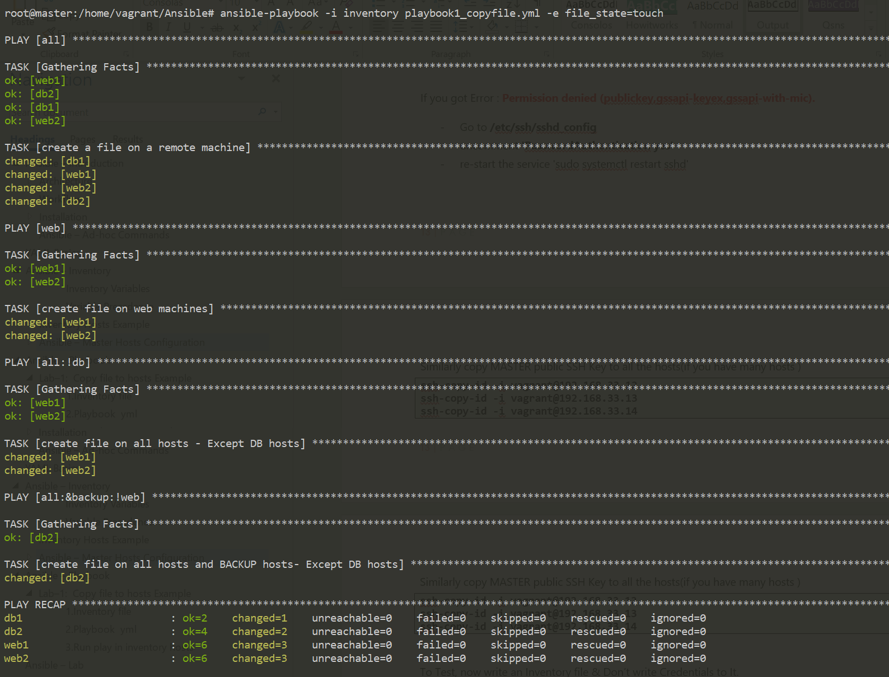
Login to each node, check files created under /tmp/ folder 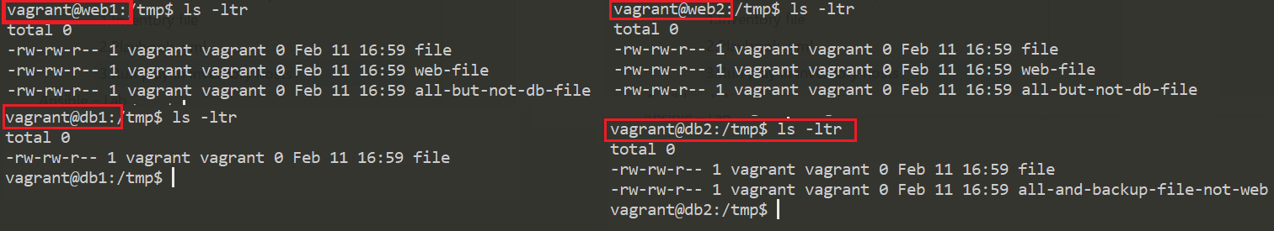

Reusable Playbooks
In Ansible, we have three ways to reuse playbooks
- includes
- imports
- roles
Includes and imports allow users to break up large playbooks into smaller files, which can be used across multiple parent playbooks or even multiple times within the same Playbook.
Roles allow more than just tasks to be packaged together and can include variables, handlers, or even modules and other plugins. Unlike includes and imports, roles can also be uploaded and shared via Ansible Galaxy.
You can then use import_tasks or include_tasks to execute the tasks in a file in the main task list:
tasks:
- import_tasks: common_tasks.yml
# or
- include_tasks: common_tasks.yml

Importing Playbooks : It is possible to include playbooks inside a master playbook. For example:
- import_playbook: webservers.yml
- import_playbook: databases.yml

Roles are ways of automatically loading certain vars_files, tasks, and handlers based on a known file structure. Grouping content by roles also allows easy sharing of roles with other users.
Role Directory Structure
Example project structure:

site.yml
webservers.yml
fooservers.yml
roles/
common/
tasks/
handlers/
files/
templates/
vars/
defaults/
meta/
webservers/
tasks/
defaults/
meta/
Roles expect files to be in certain directory names. Roles must include at least one of these directories, however it is perfectly fine to exclude any which are not being used. When in use, each directory must contain a main.yml file, which contains the relevant content:

Ansible – Roles
- In Ansible, the role is the primary mechanism for breaking a playbook into multiple files. This simplifies writing complex playbooks, and it makes them easier to reuse.
- If you need to perform 10 different tasks on 5 different systems. creating single playbook with 10 lengthy tasks, will make reading playbook confuse. To avoid this Create 10 different Roles , call them in Playbook
- Roles are not playbooks. Roles are small functionality which can be independently used but must be used within playbooks.
- There is no way to directly execute a role. Roles have no explicit setting for which host the role will apply to.
- Playbook is a collection of Roles
- Each Role will have a Specific functionality
- Ansible Roles are Independent on each other.

Create Ansible Role
To create role, we have ansible-galaxy which is comes inbuilt with ansible. We have to place roles inside /etc/ansible/roles folder
Syntax
ansible-galaxy init <rolename>

Directory Structure of Ansible Role
If you create a sample role , you will see following directory structure inside it.
ansible-galaxy init samplerole
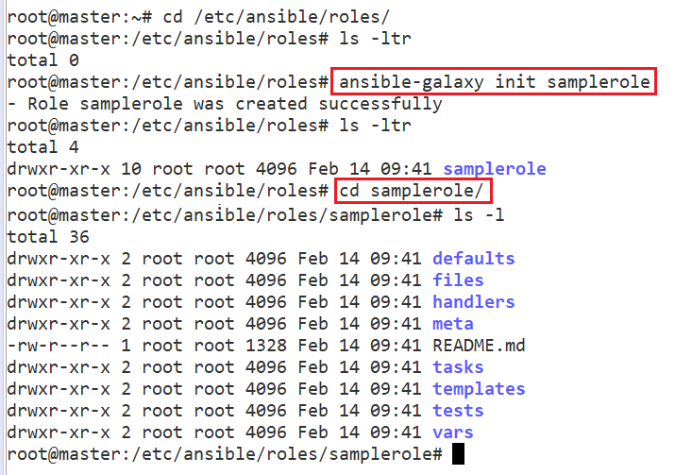
Here is a description of what each directory represents:
- defaults: This directory lets you set default variables for included or dependent roles. Any defaults set here can be overridden in playbooks or inventory files.
- files: This directory contains static files and script files that might be copied to or executed on a remote server.
- handlers: All handlers that were in your playbook previously can now be added into this directory.
- meta: This directory is reserved for role metadata, typically used for dependency management. For example, you can define a list of roles that must be applied before the current role is invoked.
- templates: This directory is reserved for templates that will generate files on remote hosts. Templates typically use variables defined on files located in the vars directory, and on host information that is collected at runtime.
- tasks: This directory contains one or more files with tasks that would normally be defined in the tasks section of a regular Ansible playbook. These tasks can directly reference files and templates contained in their respective directories within the role, without the need to provide a full path to the file.
- vars: Variables for a role can be specified in files inside this directory and then referenced elsewhere in a role.

Example : Install MEAN stack with Ansible Roles
We need to create
1. Four Roles
- Role for Installing pre-requisites
- Role for Installing Node.js
- Role for Installing MongoDB
- Role for Installing nginx & Deploying index.html
2. One Playbook

1.Careating Roles
All roles will be created under : `/etc/ansible/roles/`
a) Role for Installing pre-requisites
create `prereq` role
ansible-galaxy init prereq

create `main.yml` - tasks to install GIT
Once Role is created go to role folder & then task folder & create tasks inside an yaml file(ex: main.yml)
#/etc/ansible/roles/prereq/tasks/main.yml
---
- name: Install git
apt:
name: git
state: present
update_cache: yes

b) Role for Installing Node.js
create `nodejs` role
ansible-galaxy init nodejs

create `main.yml` - tasks to install Node.js
# /etc/ansible/roles/nodejs/tasks/main.yml
---
# tasks file for nodejs
- name: Node.js - Get script
get_url:
url: "http://deb.nodesource.com/setup_6.x"
dest: "{{ var_node }}/nodejs.sh"

- name: Node.js - Set execution permission to script
file:
path: "{{ var_node }}/nodejs.sh"
mode: "u+x"

- name: Node.js - Execute installation script
shell: "{{ var_node }}/nodejs.sh"

- name: Node.js - Remove installation script
file:
path: "{{ var_node}}/nodejs.sh"
state: absent

- name: Node.js - Install Node.js
apt: name={{ item }} state=present update_cache=yes
with_items:
- build-essential
- nodejs

- name: Node.js - Install bower and gulp globally
npm: name={{ item }} state=present global=yes
with_items:
- bower
- gulp

c) Role for Installing MongoDB
create `mongodb` role
ansible-galaxy init mongodb

create `main.yml` - tasks to install MongoDB
To setup the mongodb playbook we will do the following inside the playbook:
- Import the mongodb public key
- Add mongodb repository
- Install mongodb
- mongodb running status
---
# tasks file for mongodb
- name: MongoDB - Import public key
apt_key:
keyserver: hkp://keyserver.ubuntu.com:80
id: EA312927

- name: MongoDB - Add repository
apt_repository:
filename: '/etc/apt/sources.list.d/mongodb-org-3.2.list'
repo: 'deb http://repo.mongodb.org/apt/ubuntu trusty/mongodb-org/3.2 multiverse'
state: present
update_cache: yes

- name: MongoDB - Install MongoDB
apt:
name: mongodb-org
state: present
update_cache: yes
force: yes

- name: Start mongod
shell: "mongod &"

d) Role for Installing Nginx & index.html
create `nginx` role
ansible-galaxy init nginx

create `main.yml` - tasks to install nginx
---
# tasks file for nginx
- name: Install nginx with latest version
apt: name=nginx state=present update_cache=true force=yes
- name: Insert Index Page
template:
src: /tmp/index.html
dest: /usr/share/nginx/html/index.html
- name: start nginx
service:
name: nginx
state: started

b.Main Playbook Creation
#cd /etc/ansible/meanply.yml
---
- hosts: all
remote_user: vagrant
become: yes
become_method: sudo
vars:
#variable needed during node installation
var_node: /tmp
roles:
- prereq
- nodejs
- mongodb
- nginx

Update Hosts Inventory
we have placed single node in default host file.
#/etc/ansible/hosts
192.168.33.11

Run The playbook
sudo ansible-playbook /etc/ansible/meanply.yml -K

PLAY [all] *********************************************************************************

TASK [Gathering Facts] ****************************************************************************
ok: [192.168.33.11]

TASK [prereq : Install git] ***********************************************************************
ok: [192.168.33.11]

TASK [nodejs : Node.js - Get script] **************************************************************
changed: [192.168.33.11]

TASK [nodejs : Node.js - Set execution permission to script] **************************************
changed: [192.168.33.11]

TASK [nodejs : Node.js - Execute installation script] *********************************************
changed: [192.168.33.11]

TASK [nodejs : Node.js - Remove installation script] **********************************************
changed: [192.168.33.11]

TASK [nodejs : Node.js - Install Node.js] *********************************************************
ok: [192.168.33.11] => (item=[u'build-essential', u'nodejs'])

TASK [nodejs : Node.js - Install bower and gulp globally] *****************************************
ok: [192.168.33.11] => (item=bower)
ok: [192.168.33.11] => (item=gulp)

TASK [mongodb : MongoDB - Import public key] ******************************************************
ok: [192.168.33.11]

TASK [mongodb : MongoDB - Add repository] *********************************************************
ok: [192.168.33.11]

TASK [mongodb : MongoDB - Install MongoDB] ********************************************************
ok: [192.168.33.11]

TASK [mongodb : Start mongod] *********************************************************************
changed: [192.168.33.11]

TASK [nginx : Install nginx with latest version] **************************************************
ok: [192.168.33.11]

TASK [nginx : Insert Index Page] ******************************************************************
ok: [192.168.33.11]

TASK [nginx : start nginx] ************************************************************************
ok: [192.168.33.11]

PLAY RECAP ****************************************************************************
192.168.33.11 : ok=15 changed=5 unreachable=0 failed=0 skipped=0

Check Nginx Server
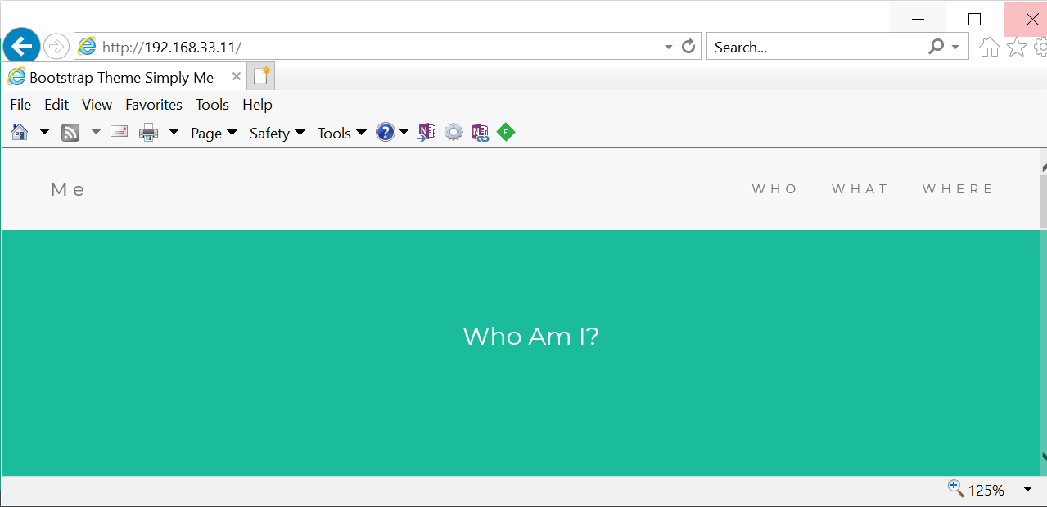

Ansible - Loops
Ansible loop provides a lot of methods to repeat certain tasks until a condition is met.
A basic example which can be used to install a lot of Linux packages can be written like the below example.
- name: Ansible Loop example
apt:
name: "{{ item }}"
state: present
with_items:
- python3
- ca-certificates
- git
In the above task, instead of writing 3 separate task we have consolidated them into a single task.In each iteration, the value of with_items block will be inserted in place of {{ item }}.

Ansible loop with Index
In some scenarios knowing the index value might come in handy. You can use the “with indexed_items” for this. The loop index will be available at item.0 and the value will be available at item.1. index value starts at zero as usual.
- hosts: all
tasks:
- name: Ansible loop with index example
debug:
msg: "echo loop index at {{ item.0 }} and value at {{item.1}}"
with_indexed_items:
- "hello1"
- "hello2"
- "hello3"

You can also make changes to the index value like addition, subtraction etc.
- name: Ansible loop with index modification example
debug:
msg: "echo loop index at {{ item.0 + 1}} and value at {{item.1}}"

Ansible loop with conditional
You can also use the “when” conditional statement along with the loop structure. Thus you can control the looping based on a variable or system facts.
The following example will run the task when the loop value is the same as the “loop_1” variable. Note that “item” is not enclosed in double brackets.
- hosts: all
vars:
loop_1: "hello1"
tasks:
- name: Ansible loop with conditional example
debug:
msg: "{{ item }}"
with_items:
- "hello1"
- "hello2"
- "hello3"
when: item == "{{ loop_1 }}"

Ansible – Tags
If you have a large playbook, it becomes useful to be able to run only a specific part of it rather than running everything in the playbook. Ansible supports a tag attribute for this reason.
When you apply tags on things, then you can control whether they are executed by adding command-line options.
When you execute a playbook, you can filter tasks based on the tags in two ways, such as:
- On the command line, with the -tags or -skip-tags options.
- In Ansible configuration settings, with the TAGS_RUN and TAGS_SKIP options.
an example that tags two tasks with different tags, such as:
tasks:
- yum:
name: "{{ item }}"
state: present
loop:
- httpd
- memcached
tags:
- packages

- template:
src: templates/src.j2
dest: /etc/foo.conf
tags:
- configuration

If you want to run the configuration and packages part of a very long playbook, then you can use the -tags option on the command line.
ansible-playbook example.yml --tags "configuration,packages"

if you want to run a playbook without certain tagged tasks, then you can use the -skip-tags command-line option.
ansible-playbook example.yml --skip-tags "packages"

Ansible – Templates
Managing configurations of multiple servers and environments are one of the significant uses of Ansible. But these configuration files may vary for each remote servers or each cluster. But apart from some few parameters, all other settings will be same.
A template in Ansible is a file which contains all your configuration parameters, but the dynamic values are given as variables. During the playbook execution, depending on the conditions like which cluster you are using, the variables will be replaced with the relevant values.
The variables in a template file will be denoted by the double curly braces, ‘{{ variables }}’. The template files will usually have the .j2 extension, which denotes the Jinja2 templating engine used.
A Basic Example
In the following task, I am using the template module on the example1.j2 file which will replace the default variables with values given in the playbook.
File: Playbook.yml
---
- hosts: all
vars:
variable1: 'Hello...!!!'
variable2: 'My first playbook using template'
tasks:
- name: Basic Template Example
template:
src: example1.j2
dest: /home/knoldus/Documents/Ansible/output.txt

File: example1.j2
{{ variable1 }}
No effects on this line
{{ variable2 }}

File: output.txt
Hello...!!!
No effects on this line
My first playbook using template
As you can see, both variables in the example1.j2 are replaced by their values.
A Basic Example of Ansible Template Module
At the bare minimum, you need to have two parameters when using the Ansible module.
src: the source of the template file. This can be relative or absolute path.
dest: the destination path on the remote server

These are some of the other parameters which we can use to change some default behavior of template module :
- force – If the destination file already exists, then this parameter decides whether it should be replaced or not. By default, the value is ‘yes’.
- mode – If you want to set the permissions for the destination file explicitly, then you can use this parameter.
- backup – If you want a backup file to be created in the destination directory, you should set the value of the backup parameter to ‘yes’. By default, the value is ‘no’. The backup file will be created every time there is a change in the destination directory.
- group – Name of the group that should own the file/directory. It is similar to executing chown for a file in Linux systems.
Using lists in Ansible templates
In the next example, I’ll be using the template module to print all the items present in a list using the for the loop.
File: Playbook.yml
- hosts: all
vars:
list1: ['Apple','Banana','Cat', 'Dog']
tasks:
- name: Template Loop example.
- template:
src: example2.j2
dest: /home/knoldus/Documents/Ansible/output.txt

File: example2.j2
Example of template module loop with a list.
{% for item in list1 %}
{{ item }}
{% endfor %}

File: output.txt
Example of template module loop with a list.
Apple
Banana
Cat
Dog
Working With Multiple Files in Ansible
We can use the with_items parameter on a dictionary to render multiple files. For example, if we want to render three templates each with different source and destination, with_items parameter can be put to use. An illustration is given below.
- hosts: all
tasks:
- name: Template with_items example.
template:
src: "{{ item.src }}"
dest: "{{ item.dest }}"
with_items:
- {src: 'example.j2',dest: '/home/knoldus/Documents/Ansible/output.txt'}
- {src: 'example1.j2',dest: '/home/knoldus/Documents/Ansible/output1.txt'}
- {src: 'example2.j2',dest: '/home/knoldus/Documents/Ansible/output2.txt'}

Ansible – Dynamic Inventory
In Ansible, a static inventory file is a plain text file that contains a list of managed hosts declared under a host group using either hostnames or IP addresses.
But in real time, inventory file keeps constantly changing as you add or decommission servers, keeping tabs on the hosts defined in the inventory file becomes a real challenge.
- Ansible will accept any kind of executable file as an inventory file, so you can build your own dynamic inventory however you like, as long as you can pass it to Ansible as JSON.
- A dynamic inventory is a shell script written in Python, PHP or any other programming language. It comes in handy in cloud environments such as AWS where IP addresses change once a virtual server is stopped and started again.
- Ansible already has developed inventory scripts for public cloud platforms such as Google Compute Engine, Amazon EC2 instance, OpenStack, RackSpace, cobbler, among others
Utilize an Existing Dynamic Inventory Script
A script that is used to create a dynamic inventory has to be made executable so that Ansible can use it.
To retrieve information about the hosts inside a dynamic inventory script simply run.
# ./script --list
As pointed earlier, the output should be in JSON in the format below.
Sample Output
{
"webservers": {
"hosts": [
"webserver1.example.com",
"webserver2.example.com"
],
"vars": {}
},
"database_servers": {
"hosts": [
"mysql_db1",
"mysql_db2"
],
"vars": {}
},
"_meta": {
"hostvars": {
"mysql_db2": {},
"webserver2.example.com": {},
"webserver1.example.com": {},
"mysql_db1": {}
}
}
}

To use this
ansible-playbook my_playbook.yml -i ./dyn_inv.py

Ansible – Tower
Ansible Tower is web-based edition of Terminal based Ansible. Below are its features
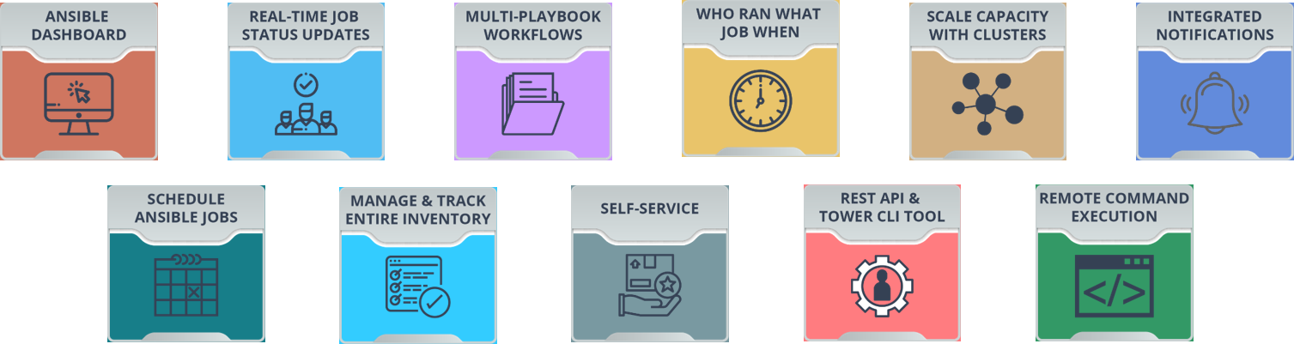

Read More : https://www.edureka.co/blog/ansible-tower/
Ansible Tower – Jenkins Configure
https://www.ansible.com/blog/ansible-tower-jenkins-in-under-5-minutes

Ansible – Lab
Our company have complex multitier applications. Each of these applications contains many servers, like - load balancers(LB), web servers(WWW), database servers(DB), caching applications, and middleware queues etc.
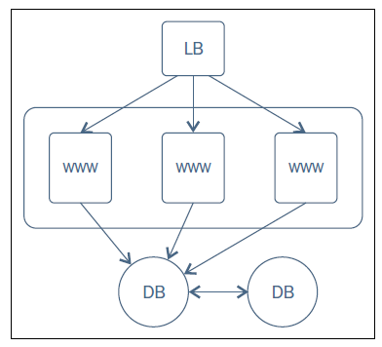
Example policies and the sequence in which those are to be applied is shown in the following steps:
1.Database servers(DB)
- Install & configure MySQL
2.Web Servers(WWW)
- Install & configure Nginx with PHP bindings.
- Deploy a WordPress application in Webservers and add respective configurations to Nginx.
3.Load Balancers(LB)
- Install & configure HaProxy service on the load balancer hosts
- Update haproxy configurations with the hostnames of all the web servers created earlier.
The following is a sample playbook that translates the infrastructure blueprint into policies enforceable by Ansible.
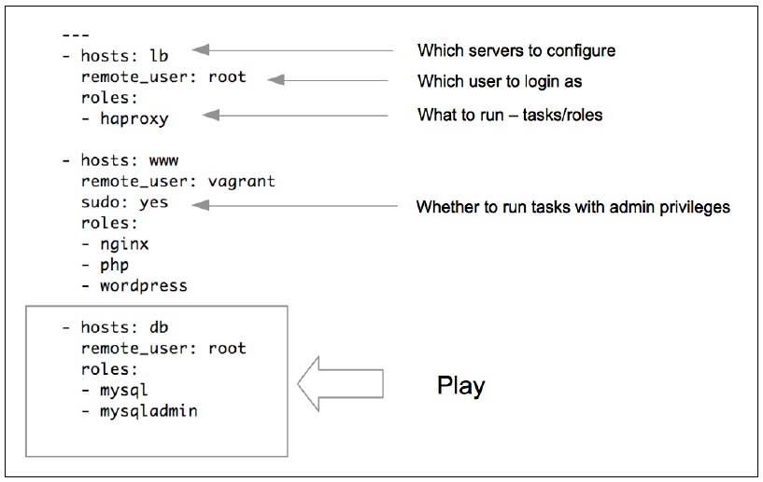

Task 1: Create a user, install htop & nginx on all hosts.
- Create a 'devops' user under 'DevOps' group on all hosts.
- Install the "htop" utility(upgrade alternative to top command).
- Install Nginx on all web servers and start it as a service.
p3_ngnix_usergroup.yml
---
- hosts: all
remote_user: vagrant
become: yes
become_method: sudo
tasks:
- name: create devops group
group: name=devops state=present
- name: create devops user with admin previleges
user: name=devops comment="Devops User" uid=2001 group=devops
- name: install htop package
action: apt name=htop state=present update_cache=yes

- hosts: web
user: vagrant
become: yes
become_method: sudo
tasks:
- name: Install nginx with latest version
apt: name=nginx state=present update_cache=true force=yes
- name: start nginx
service:
name: nginx
state: started
inventory1_lb
[all]
web1 ansible_ssh_host=web1.satyacodes.vm ansible_user=vagrant
web2 ansible_ssh_host=web2.satyacodes.vm ansible_user=vagrant
db1 ansible_ssh_host=db1.satyacodes.vm ansible_user=vagrant
db2 ansible_ssh_host=db2.satyacodes.vm ansible_user=vagrant
lb ansible_ssh_host=lb.satyacodes.vm ansible_user=vagrant
[web]
web1
web2
[db]
db1
db2
[backup]
db2
[lbs]
lb

Run Playbook
ansible-playbook -i inventory_lb p3_ngnix_usergroup.yml
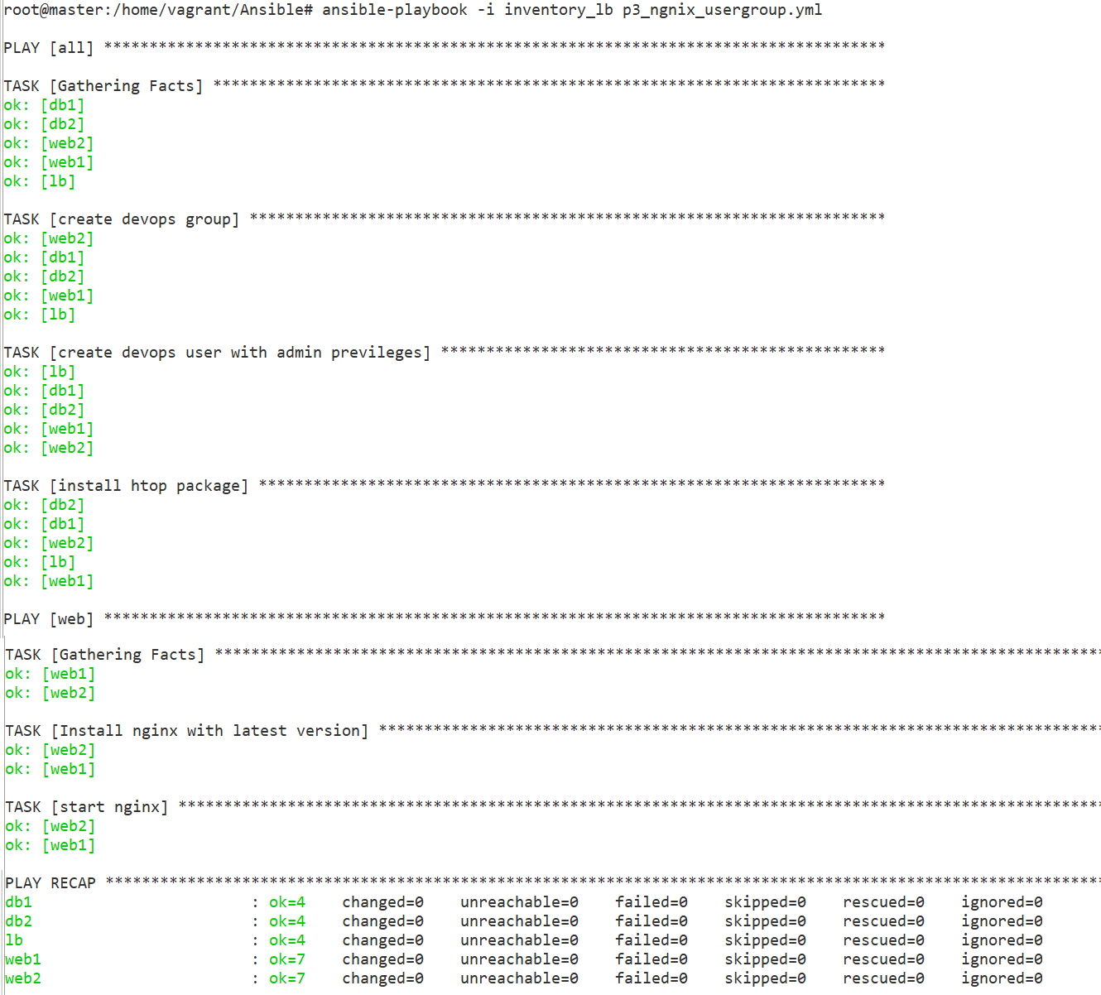

Task 2 – WordPress Install

Step 1 — Installing Ansible
In this section we’ll install Ansible on your build-server. SSH into your build-server and run this command to install Ansible:
sudo apt-get install ansible -y

You can make sure that Ansible is installed by running:
ansible --version

Step 2 - Create Roles
Create a directory for our playbook.
mkdir wordpress

Create two files: playbook.yml, hosts
touch playbook.yml
touch hosts

split our playbooks up into roles. For this project we’ll create four roles.
- server
- php
- mysql
- wordpress

From the project root folder (~/wordpress), create a directory called roles and cd into it:
mkdir roles && cd roles

we will create above roles inside roles directory(/home/vagrant/Ansible/wordpress/roles). For each role that we want to create, we will run ansible-galaxy init:
ansible-galaxy init server
ansible-galaxy init php
ansible-galaxy init mysql
ansible-galaxy init wordpress

At this point we should have the following file structure:
[.]
|_ playbook.yml
|_ hosts
|_ [roles]
|_ [server]
|_ ...
|_ [php]
|_ ...
|_ [mysql]
|_ ...
|_ [wordpress]
|_ ...

a. server Role
1.Write server's yml file, which does the following:
- Update the apt-cache (apt-get update)
- apt-get install Apache, MySQL, PHP, and related software
# roles/server/tasks/main.yml
---
- name: Update apt cache
apt: update_cache=yes cache_valid_time=3600
become: yes
become_method: sudo

- name: Install required software
apt: name={{ item }} state=present
become: yes
become_method: sudo
with_items:
- apache2
- mysql-server
- php5-mysql
- php5
- libapache2-mod-php5
- php5-mcrypt
- python-mysqldb

b.PHP role
will install the required PHP extensions.
roles/php/tasks/main.yml
---
- name: Install php extensions
apt: name={{ item }} state=present
become: yes
become_method: sudo
with_items:
- php5-gd
- libssh2-php

c.MySQL Role
We also need to set up a MySQL database for our WordPress site. We’ll do this in the mysql role.
This role does the following:
- Create a MySQL database
- Create a MySQL user
- Give that user access to our database
roles/mysql/tasks/main.yml
# roles/mysql/tasks/main.yml
---
- name: Create mysql database
mysql_db: name={{ wp_mysql_db }} state=present

- name: Create mysql user
mysql_user:
name={{ wp_mysql_user }}
password={{ wp_mysql_password }}
priv=*.*:ALL

We’re going to need a few variables for this one. For a role, you can specify default values for any variables in the defaults/main.yml file.
nano roles/mysql/defaults/main.yml

Add your database name, database username, and database password (that you want to create), in that order. Make sure you pick a secure wp_db_password.
roles/mysql/defaults/main.yml
---
# defaults file for mysql
wp_mysql_db: wordpress
wp_mysql_user: admin
wp_mysql_password: admin

d.WordPress
We’re adding a few different tasks to the roles/wordpress/tasks/main.yml file
- First we need to download WordPress to the /tmp
- extract the gzip file to /var/www, the location that Apache uses for storing web content
- update Apache’s default site document root to point to our WordPress site:
- Update constants in this file to match our database information:
# roles/wordpress/tasks/main.yml
---
- name: Download WordPress
get_url:
url=https://wordpress.org/latest.tar.gz
dest=/tmp/wordpress.tar.gz
validate_certs=no

- name: Extract WordPress
unarchive: src=/tmp/wordpress.tar.gz dest=/var/www/ copy=no
become: yes
become_method: sudo

- name: Update default Apache site
become: yes
become_method: sudo
lineinfile:
dest=/etc/apache2/sites-enabled/000-default.conf
regexp="(.)+DocumentRoot /var/www/html"
line="DocumentRoot /var/www/wordpress"
notify:
- restart apache

- name: Copy sample config file
command: mv /var/www/wordpress/wp-config-sample.php /var/www/wordpress/wp-config.php creates=/var/www/wordpress/wp-config.php
become: yes
become_method: sudo

- name: Update WordPress config file
lineinfile:
dest=/var/www/wordpress/wp-config.php
regexp="{{ item.regexp }}"
line="{{ item.line }}"
with_items:
- {'regexp': "define\\('DB_NAME', '(.)+'\\);", 'line': "define('DB_NAME', 'wordpress');"}
- {'regexp': "define\\('DB_USER', '(.)+'\\);", 'line': "define('DB_USER', 'admin');"}
- {'regexp': "define\\('DB_PASSWORD', '(.)+'\\);", 'line': "define('DB_PASSWORD', 'admin');"}
become: yes
become_method: sudo

we can replace with Variables as well
with_items:
- {'regexp': "define\\('DB_NAME', '(.)+'\\);", 'line': "define('DB_NAME', '{{wp_mysql_db}}');"}
- {'regexp': "define\\('DB_USER', '(.)+'\\);", 'line': "define('DB_USER', '{{wp_mysql_user}}');"}
- {'regexp': "define\\('DB_PASSWORD', '(.)+'\\);", 'line': "define('DB_PASSWORD', '{{wp_mysql_password}}');"}
become: yes
become_method: sudo

We need to add our handler for restart apache. Save what you have so far, and open roles/wordpress/handlers/main.yml for editing:
roles/wordpress/handlers/main.yml
---
- name: Restart Apache for Wordpress
service: name=apache2 state=restarted
become: yes
become_method: sudo

Inventory (hosts file)
Edit hosts& Add the line for [wordpress], and below it, the IP address of your wordpress-server:
hosts
[wordpress]
192.168.33.11 ansible_user=vagrant
192.168.33.12 ansible_user=vagrant

playbook.yml
root@master:/home/vagrant/Ansible/wordpress# cat playbook.yml
---
- hosts: wordpress
remote_user: vagrant
become: yes
become_method: sudo

roles:
- server
- php
- mysql
- wordpress

Test
We’re done! Run the playbook to install and configure WordPress:
ansible-playbook playbook.yml -i hosts

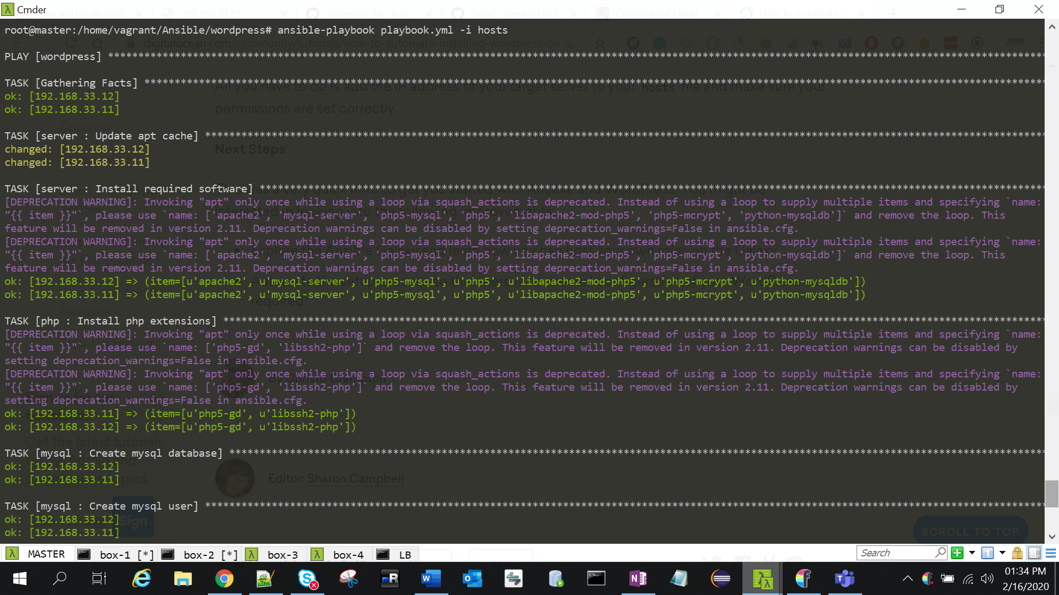
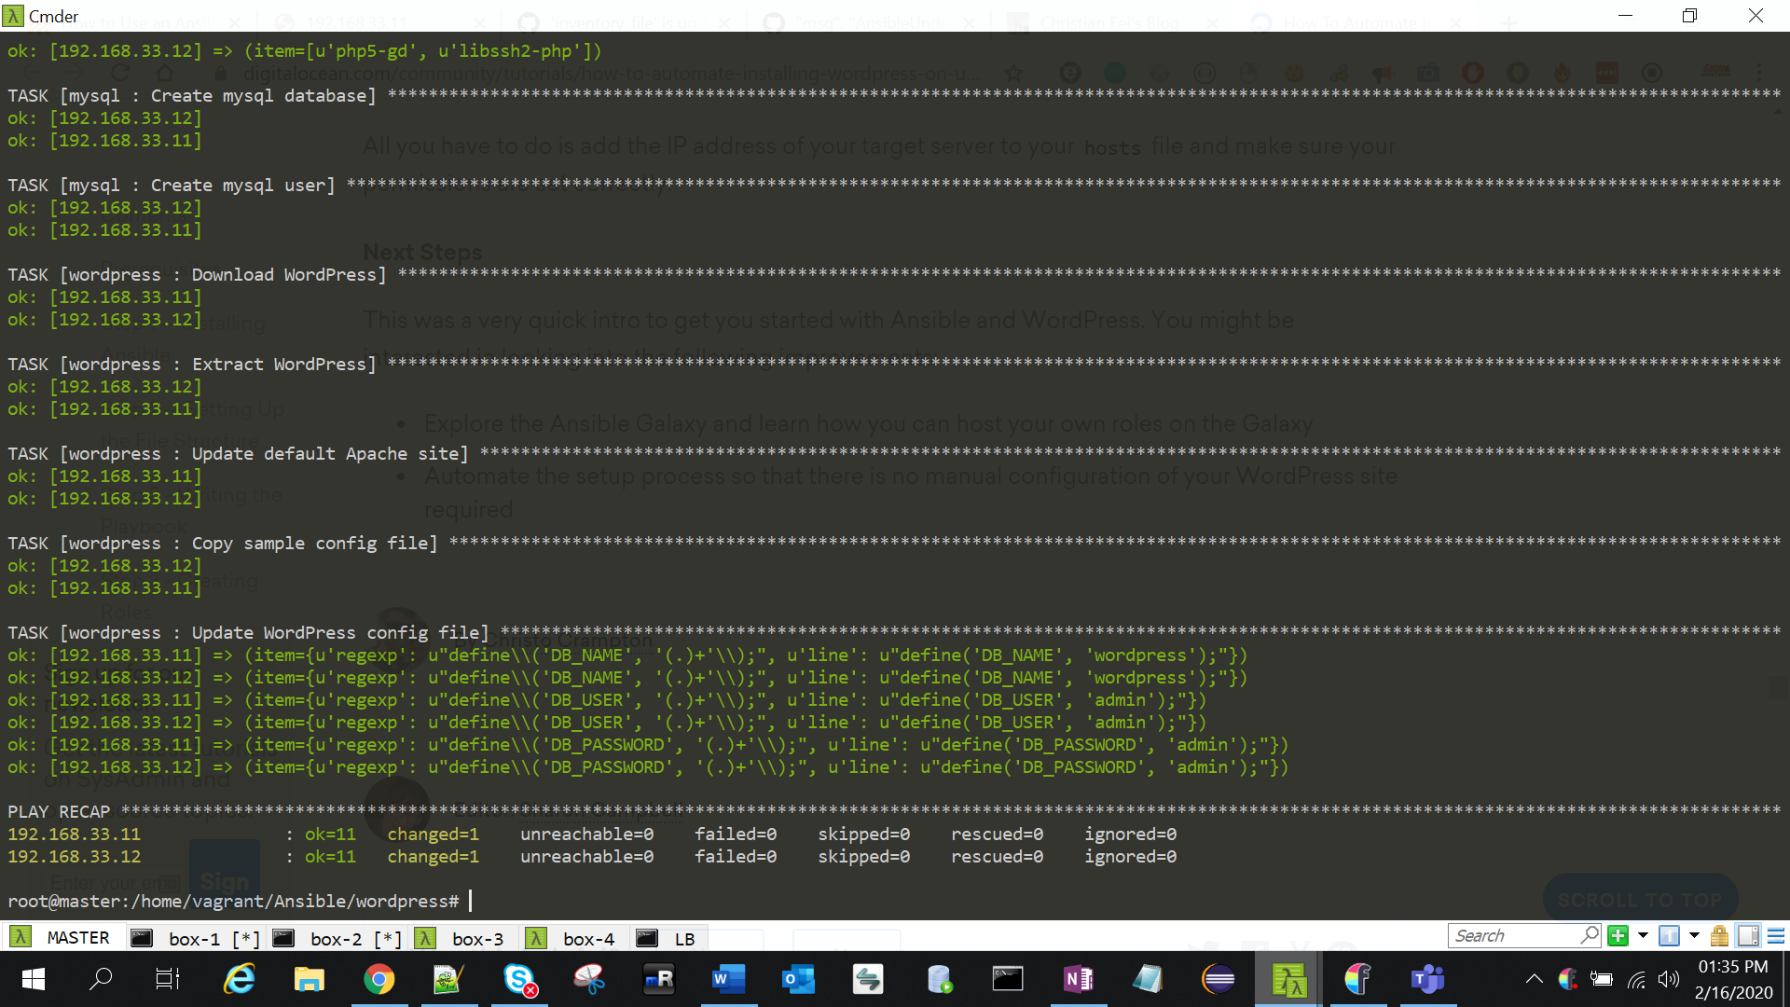
sudo /etc/init.d/apache2 stop
sudo /etc/init.d/apache2 start
sudo service apache2 restart

Errors

1."Failed to lock apt for exclusive operation"
Put:
become: yes
Now everything works as intended
---
- hosts: all
remote_user: vagrant
become: yes
become_method: sudo

2. /usr/bin/apt-get -y -o Dpkg::Options::=--force-confdef -o Dpkg::Options::=--force-confold install 'nginx'' failed:
Use `force=yes` Option while doing apt:
apt: pkg=nginx state=installed update_cache=true force=yes
Ref : https://docs.ansible.com/ansible/latest/modules/apt_module.html

3 .To display OUTPUT in readable format
ANSIBLE_STDOUT_CALLBACK=debug

or
ansible-playbook ... | sed 's/\\n/\n/g'

use plugin
To use it, edit your ansible.cfg file (either global, in /etc/ansible/ansible.cfg, or a local one in your playbook/project), and add the following lines under the [defaults] section:
# Use the YAML callback plugin.
stdout_callback = yaml
# Use the stdout_callback when running ad-hoc commands.
bin_ansible_callbacks = True

4.fatal: [192.168.33.11]: FAILED! => msg: '''wp_mysql_db'' is undefined'
fatal: [192.168.33.12]: FAILED! =>
msg: '''wp_mysql_db'' is undefined'
Remove {{}} varibles from scipt & provide statsic values

5.Your VM has become "inaccessible." Unfortunately, this is a critical error
Open VirtualBox > Find the VM > Remove
And hit vagrant up again

Ref.
https://docs.ansible.com/ansible/latest/user_guide/playbooks_intro.html
https://www.youtube.com/watch?v=cyylA0Yfn2o&list=PL8cE5Nxf6M6YUaKyuon-AWRDNr31ANuo2&index=9
https://www.digitalocean.com/community/tutorials/how-to-use-ansible-roles-to-abstract-your-infrastructure-environment
https://dotlayer.com/how-to-use-an-ansible-playbook-to-install-wordpress/
https://www.infinitypp.com/ansible/
https://www.digitalocean.com/community/tutorials/how-to-automate-installing-wordpress-on-ubuntu-14-04-using-ansible

